0 notifications total
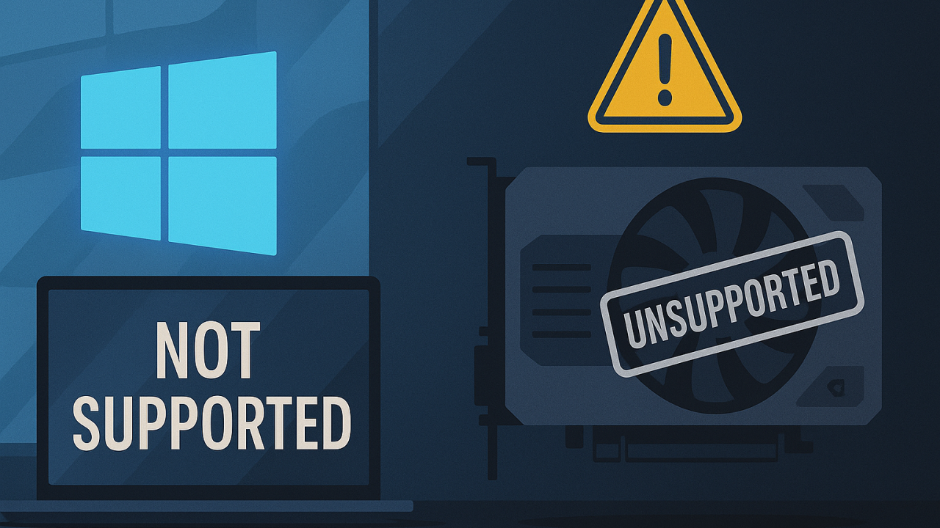
Installing Windows 11 on an Unsupported PCs and Installing Nvidia Drivers on Unsupported Windows Versions



Let's BIM Together

727 followers
October 18, 2025
Part 1: Introduction
Note: This is for x64 devices. I haven't tested or researched ARM devices.
Windows 10 is now out of support, and it won't be long before it becomes a playground for exploits, a target for malicious actors and "ethical hacker" hobbyists alike. Upgrading to Windows 11 is the right thing to do, but you may find that it can't be installed on your machine (for example, if you have a 7th generation Intel processor or older). Fortunately, you can either purchase additional support from Microsoft, or you can try workaround that seems to work well, for me at least. I've successfully installed Windows 11 on 4th and 7th generation processors, and they are running great. You will miss out on some features you likely don't care about / are not aware of (assumption since you are running aging hardware). There's also a risk: you could lose data or damage hardware. Hardware damage is unlikely, but during my learning journey here, I did have to wipe one of my drives... I'll cover how that happened and how to avoid that route. Either way, proceed at your own risk after doing your research. I should also mention: don't do this in a commercial environment. The risk of running unsupported hardware with workarounds isn't worth the liability, even if the chance of failure is small. Also, if you have cybersecurity insurance, you might want to run this by them first to avoid a surprise on your future claim (they won't be thrilled.) Lastly, before jumping to the instructions, keep in mind that Microsoft is "going to remove workarounds" to install Windows 11 with an offline username in about a month, requiring a Microsoft account sign-in instead. If you like offline accounts and plan on installing a fresh copy of Windows 11 soon, you might as well do it sooner. For more information about that, you can read this article: Microsoft confirms Windows 11 requires a Microsoft account, internet in OOBE.
Part 2: Confirm GPT partition
Confirm you have a GPT partition. Windows 11 cannot be installed on MBR. To check partition scheme do the following:
- Open Command Prompt as Administrator
- Enter command: diskpart
- Enter command: list disk
Disk ### Status Size Free Dyn Gpt
-------- ------------- ------- ------- --- ---
Disk 0 Online 931 GB 1024 KB *
You will see an output similar to above. An asterisk (*) in the "Gpt" column indicates it is GPT, which is what you want, and you can proceed to Part 3: Installing Windows 11. If you have an MBR partition, jump to the Part 4: Changing MBR to GPT Partition without Losing Data of this blog.
Part 3: Installing Windows 11
Note: Make sure you have a GPT partition before proceeding!
- Download Windows 11 Disk Image (ISO) for x64 devices
- Open Notepad and paste the following:
Windows Registry Editor Version 5.00

[HKEY_LOCAL_MACHINE\SYSTEM\Setup\MoSetup]
"AllowUpgradesWithUnsupportedTPMOrCPU"=dword:00000001

[HKEY_LOCAL_MACHINE\SYSTEM\Setup\LabConfig]
"BypassTPMCheck"=dword:00000001
"BypassRAMCheck"=dword:00000001
"BypassSecureBootCheck"=dword:00000001
- Save the file to desktop & call it Win11BypassChecks.reg
- Open Win11BypassChecks.reg from you desktop.
- Restart your PC.
- Open the downloaded Windows ISO, which will be mounted as a DVD drive. Run setup.exe from the DVD drive.
- Follow the prompts to install Windows. OPTIONAL: During the process, when you're asked to sign in with a Microsoft account, you can skip this by disconnecting from the internet. Either unplug the ethernet cable or enter ipconfig /release in the Command Prompt. The login screen will disappear and you can plug the ethernet cable back in or enter in the Command Prompt: ipconfig /renew
- You are all done, no need to keep reading, unless you interested in Part 5: Installing an Nvidia Drivers on an Unsupported Windows Version.
Part 4: Changing MBR to GPT Partition without Losing Data
Note: You don't have to do this if you already have a GPT partition.
On one of the four machines I did the upgrades on, I installed Windows 11 on an MBR partition... I had to fire up Windows from a bootable USB and reformat the partition, losing all my files on it. It wasn't a big deal because of having backups, but it was definitely a bummer and an eye-opener. To avoid this, if you have an MBR partition, convert it to GPT with the following steps:
- Open Command Prompt as Administrator.
- Enter command: mbr2gpt /convert /allowfullos
- When it finishes successfully, reboot.
- In BIOS, switch boot mode from Legacy/CSM to UEFI. (You'll have to Google or YouTube this, as it depends on your PC type, like Dell, etc.)
You should also read the official article from Microsoft regarding this.
Part 5: Installing an Nvidia Drivers on an Unsupported Windows Version
If you're upgrading from Windows 10 to Windows 11 using the method in Part 3: Installing Windows 11 with the option to keep your personal data, the Nvidia drivers should still be there. However, if you do a clean install, you'll need to reinstall your Nvidia driver, and chances are, since your CPU doesn't support Windows 11, your graphics card won't have an available driver for Windows 11 either. At least, that's what happened to me.
Luckily, you can easily trick your Nvidia driver into installing on Windows 11. In this example, we'll install a driver for the NVIDIA Quadro K5100M. I downloaded the driver from the Dell website and extracted it to a folder named NVIDIA on my desktop. ( If you download drivers directly from the Nvidia website, refer to this article for instructions on extracting drivers from their installation files. ) Once you extract the files, do the following:
- Navigate to the NVIDIA folder (or whichever folder you extracted the files to).
- In the Display.Driver folder, open the nvdm.inf file with Notepad if you downloaded the driver from the Dell website. If you downloaded the driver from the Nvidia website, open the nv_dispi.inf file with Notepad.
- In Notepad, press CTRL+F ( Find ) and search for the line that starts with [NVIDIA_Devices.NTamd64.10.0
- For me, that was [NVIDIA_Devices.NTamd64.10.0...14310] which corresponds to a Windows 10 build. Replace this line with [NVIDIA_Devices.NTamd64.10.0.22000.2] which corresponds to a Windows 11 build. This will make the driver think it's meant to be installed on Windows 11. Save the file and close Notepad.
- Click Start, type Device Manager and open it.
- In Device Manager, expand Display Adapters, right-click the display adapter, select Update driver, and then choose Browse my computer for drivers.
- Browse to the modified nvdm.inf ( or nv_dispi.inf ) file in the extracted folder, open it, select your graphics card, and click Next to install. Finally, restart your PC, and you're good to go.
- ( If you encounter an "unsigned driver" warning, you need to enable test mode. Open Command Prompt as Administrator, enter command bcdedit /set testsigning on and restart your PC. Then try installing the driver again. )

